DISABILTY AND EDUCATION: THE PATH FROM THE PAST TO THE PRESENT
Education for those with disabilities is once again undergoing change. The history of continuous change has been chequered. In the ancient past people born with disabilities were considered as less than human and a burden on society. A routine solution to this problem was to expel them from communities and to leave then to die. This phase lasted for centuries before any change occurred.
The Historical Chronology:
As the above phase passed some families became aware that certain family members with disabilities had the capacity to learn. If the family had sufficient wealth and the desire to keep a disabled family member in the home, some provided these family members with tutors and so that they remained part of the family.
With the passage of more centuries a few, and then more nations, developed non-educational holding institutions for children with various disabilities. Typically, these institutions were little better than jails.
Eventually, this step was followed by the first residential schools for children with sensory and physical disabilities. The children attending these schools had little contact with their families. Thus, the first formal schools for students with disabilities appeared in some nations. These schools had no relationship to the education system for students without disabilities. In not a few nations, residential schools continue as a mainstay for students with disabilities.
As the 19th century approached the move to residential schools broadened and the first day schools in parallel with ‘regular schools’ began for students with disabilities. However, students with disabilities still had no contact with schools attended by those without disabilities. Segregation of the two groups of students remained the universal approach throughout this century.
The next step was the introduction of schools focused individual disabilities in addition to the institutions and residential schools already noted. Students in these schools also had no contact with the school system for students without disabilities and little contact with their families.
The traditional segregation barrier was breached In the mid 20TH century. A selected set of students with disabilities were placed in regular schools for non-disabled students. They were taught by Special Education Teachers in a Special Education Class. Reliance on Special Schools and Special Classes remained the common response to students with disabilities.
Again, with the passage of time and changing understanding of those in charge of education, some students with disability with the requisite academic ability were placed full-time in regular classes. There were two parts under this final addition to the Special Education Model. The difference in the two depended on the degree of Special Teacher support needed by the regular classroom teacher and on depending on the academic ability of the students at this level. In some instances a fair degree of in-class Special Teacher support in planning and teaching suggestions was viewed as necessary. In the second of the two parts the Special Teacher acted more as an on-call consultant as this final group of students with disabilities had stronger basic academic strength.
With these final additions all of the elements of the Special Education Model were in place. Following is a schematic of the present-day Model. The schematic is often referred to Deno’s Cascade after Deno (1970) who first put all the pieces together in a schematic.
SPECIAL EDUCATION MODEL
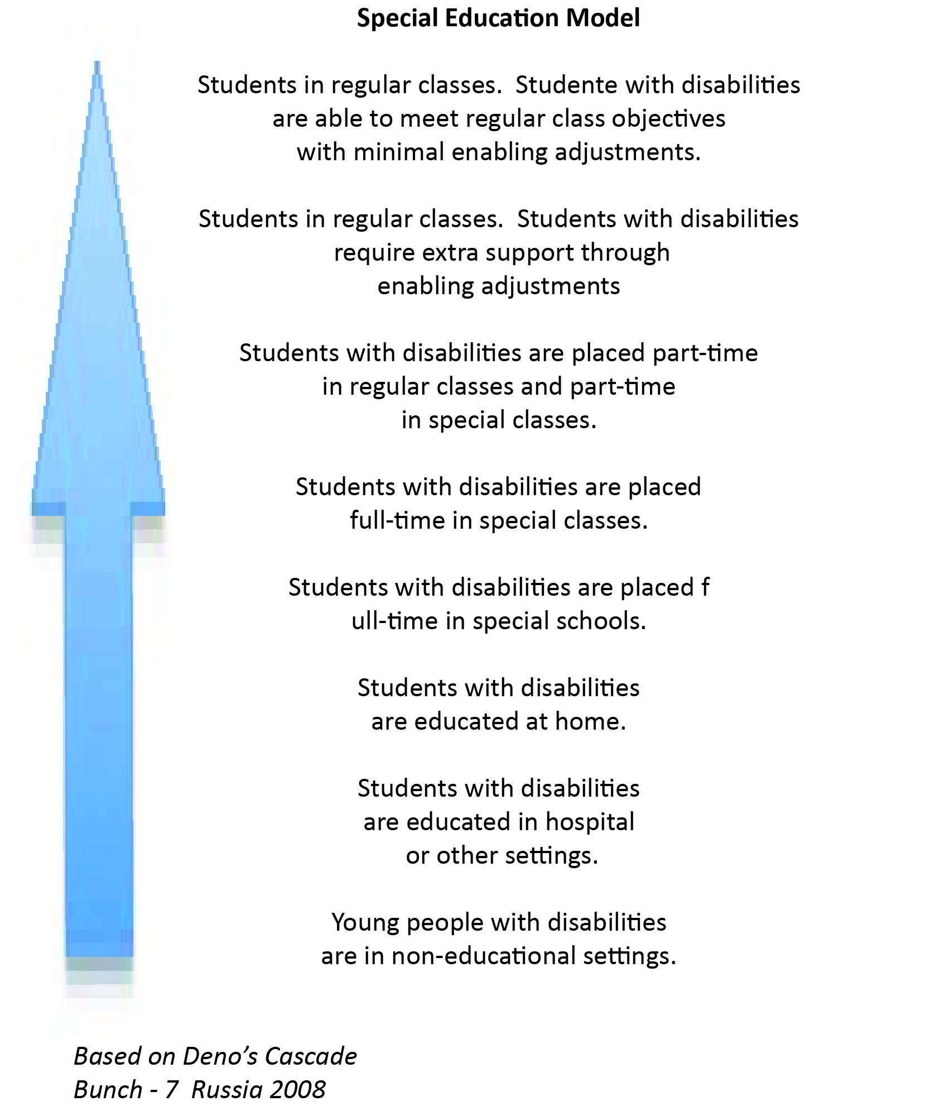

The thrust of the Special Education Model is for placement of students with disabilities in the level of their perceived academic ability. They may be moved up or down on the Model if change in their academic ability is perceived. It is the Special Education Teacher who is responsible for all decisions regarding students with disabilities.
The nations of our world are well familiar with the Special Education Model. The full Model, or aspects of it, have characterized the approach to education and disability on the global level for many centuries. While the full Special Education Model is now in force in many nations, there are many others in which the entire Model is not in place.
The traditional Special Education Model for students with disabilities as described above is being challenged by the recently advocated Inclusive Education Model. Education systems around the globe now must consider their direction for the future: to continue with a form of the Special Education Model or to move to the new Model. Two United Nations policy announcements on the issue, the 1994 UNESCO Salamanca Statement and Framework for Action and the 2006 UN Convention on the Rights of Persons with Disabilities, lay out the UN position in the following.
The 1994 UNESCO Statement and Framework for Action
UNESCO convened a meeting of experts in education and disability from all nations in 1994. The outcome of the meeting was a global policy decision for nations to move away from the Special Education Model to an inclusive approach to education and disability. The following Statement ensued.
We believe and proclaim that:
. every child has a fundamental right to education, and must be given the opportunity to achieve and maintain an acceptable level of learning,
. every child has unique characteristics, interests, abilities and learning needs,
. education systems should be designed and educational programs implemented to take into account the wide diversity of these characteristics and needs.
. those with special educational needs must have access to regular schools which should accommodate them with a child-centred pedagogy capable of meeting their needs.

Note: The term “inclusion” as applied to persons with disabilities and education was first used at a meeting convened in Toronto, Ontario, Canada at a meeting of people with disabilities, parents and advocates in 1989 under the auspices of what is now The Marsha Forest Centre. Those attending believed the term “Special Education” was not sufficiently positive to lead to equitable involvement of persons with disabilities in all aspects of society. The result of their discussion was to coin the new term. The term “Inclusive Education” was soon also was used by the UN and its agencies. (Vaughn). It is not known whether the Toronto discussion affected the UN decision.
. regular schools with this inclusive education orientation are the most effective means of combating discriminatory attitudes, creating welcoming communities, building an inclusive society and achieving education for all; moreover they provide an effective education to the majority of children and prove the efficiency and ultimately the cost-effectiveness on the entire school system.
The UNESCO Statement and Framework for Action was followed by the 2006 Convention on the Rights of Persons with Disabilities. Article 24 on Education underlines the Salamanca Statement directed to the rights of all children in relation to their education.
The Inclusive Education Model that arises from the above is designed to provide education for students with disabilities in the same classrooms or other educational settings as their peers without disability. The direction of thrust called for results in a model of education radically different than the Special Education Model. It is one in which all students learn together in a setting where regular teachers are responsible for all students and their programs. The regular teacher may call on the advice or assistance of Special Education Teachers, but where there is no doubt who is the responsible teacher. In addition to those professionals noted, there also is a significant role to be played by the regular class peers and the parents.

INSERT INCLUSIVE EDUCATION MODEL
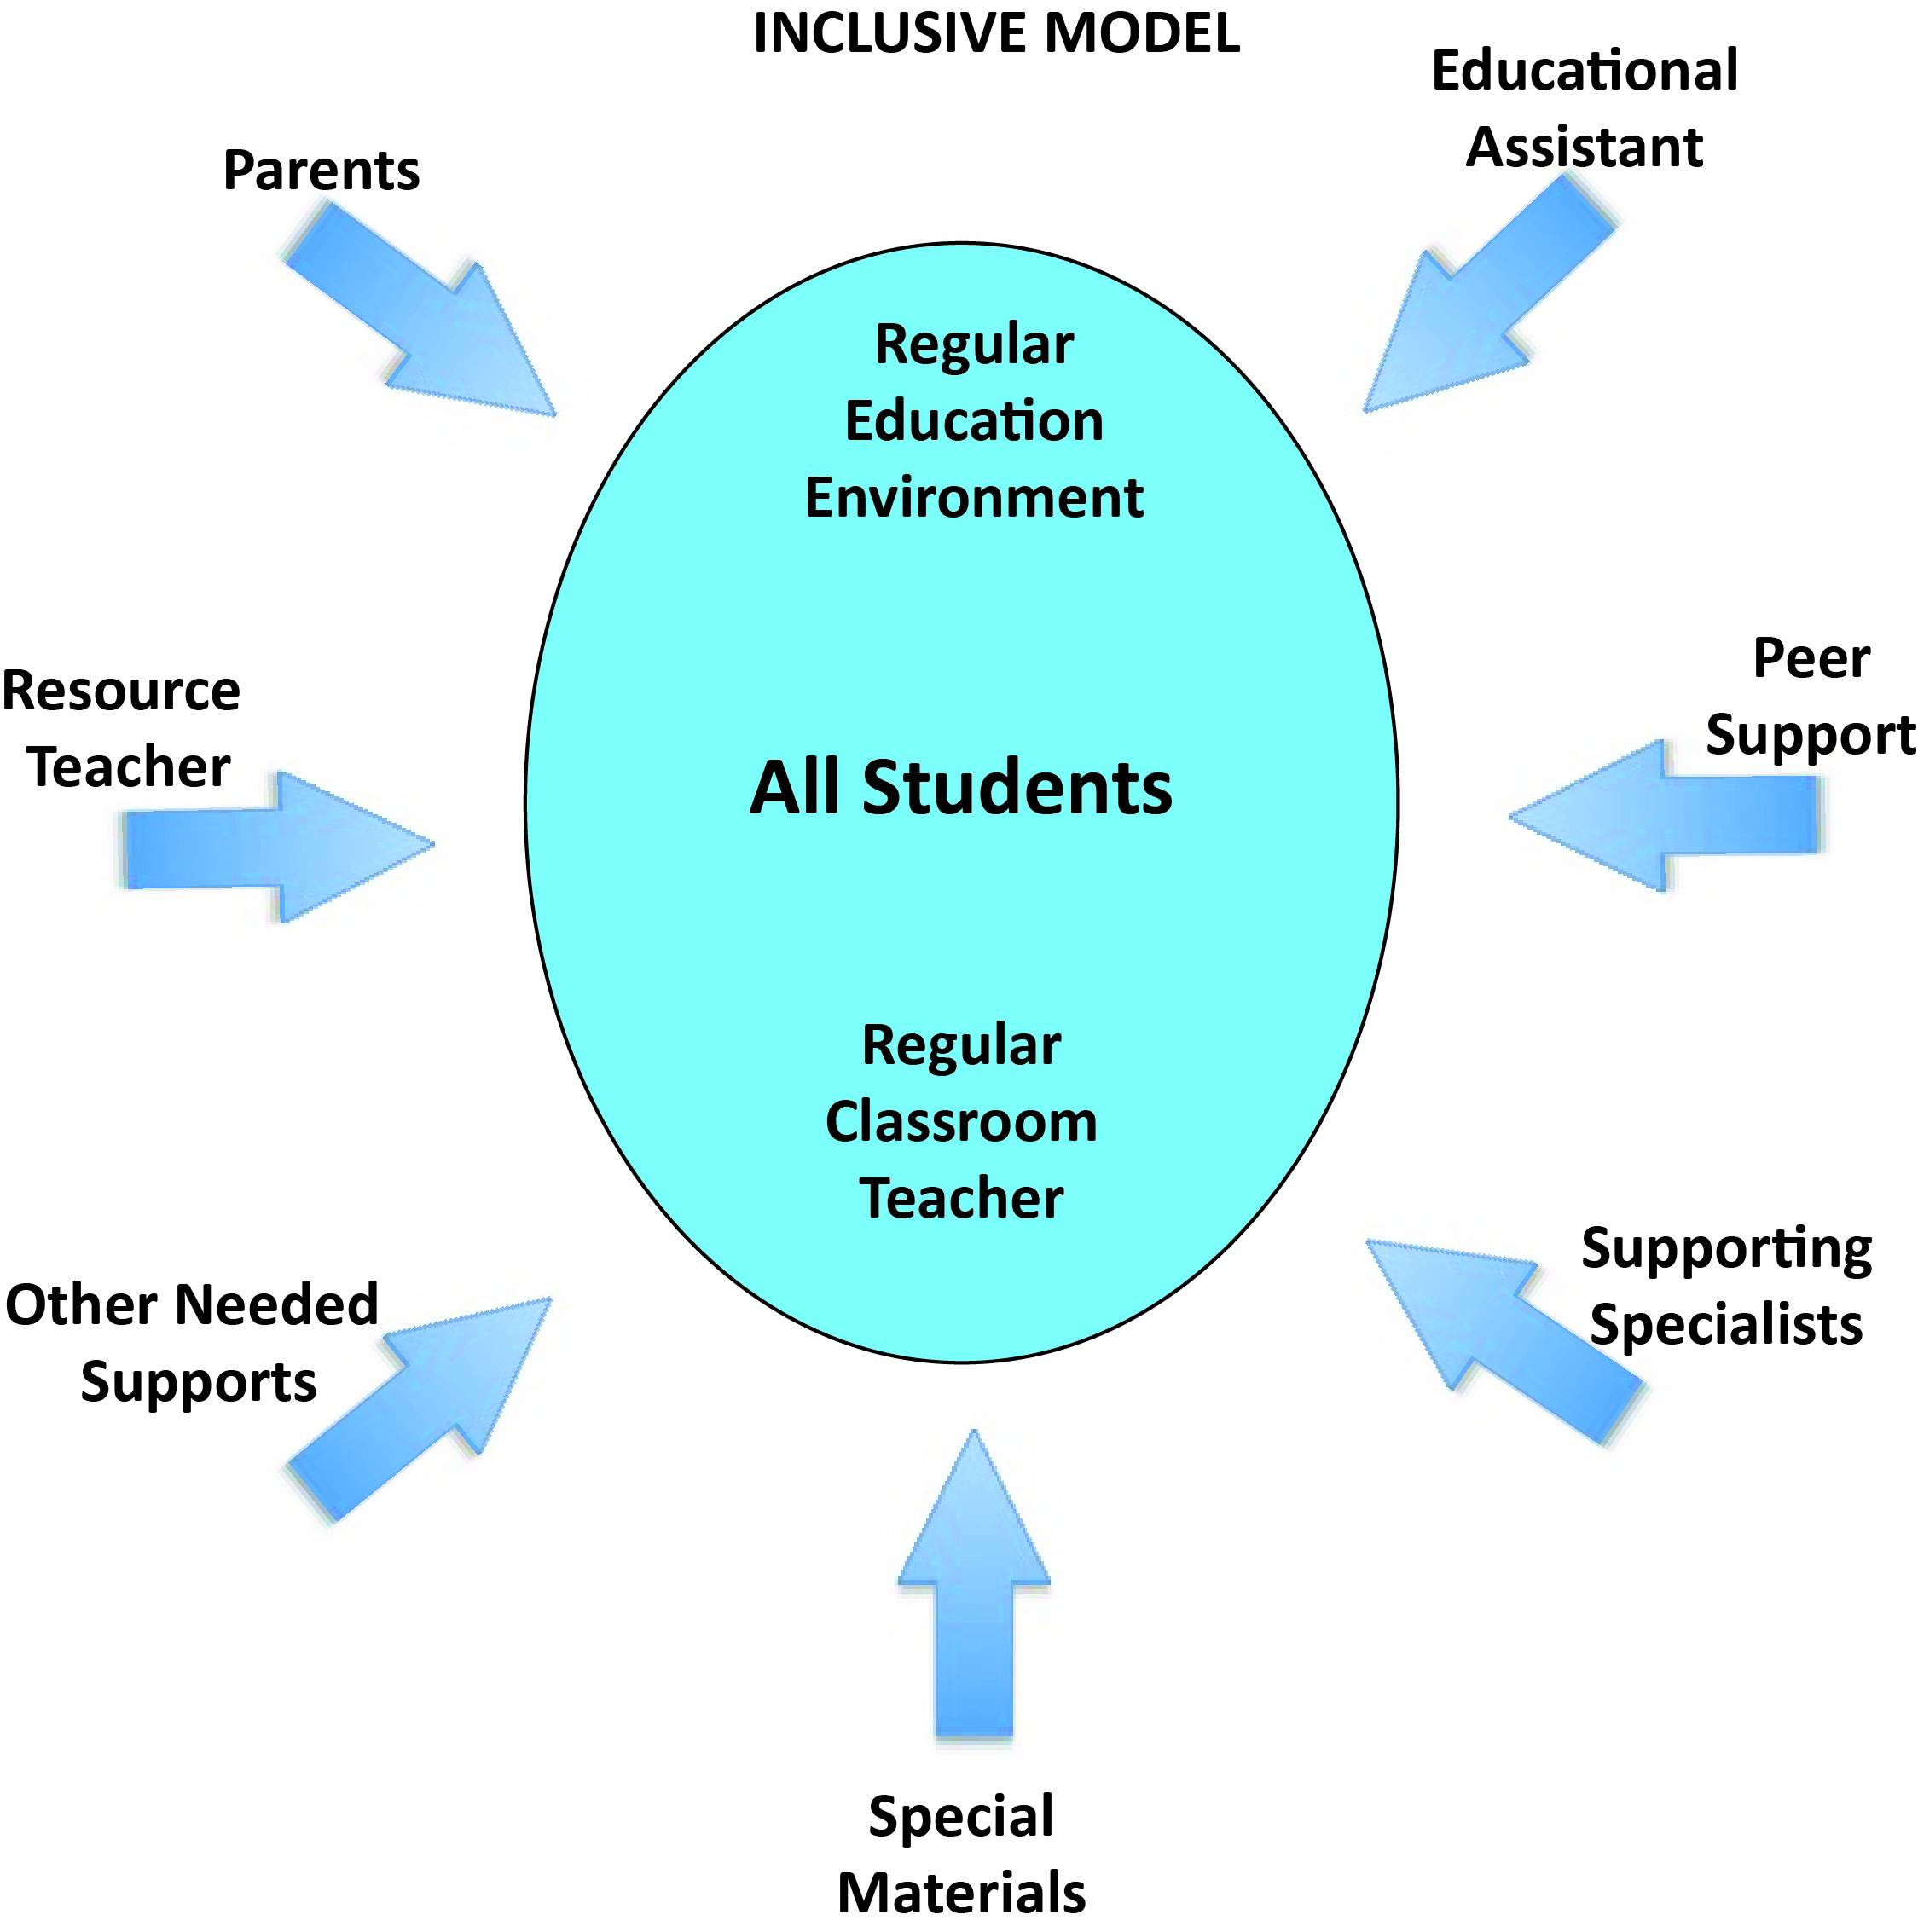

CONVENTION ON THE RIGHTS OF PERSONS WITH DISABILITIES
Article 24 – Education
1.States Parties recognize the right of persons with disabilities to education. With a view to realizing this right without discrimination and on the basis of equal opportunity, States Parties shall ensure an inclusive education system at all levels and life long learning directed to:
a. The full development of human potential and sense of dignity and self-worth, and the strengthening of respect for human rights, fundamental freedoms and human diversity;
b. The development by persons with disabilities of their personality, talents and creativity, as well as their mental and physical abilities, to their fullest potential;
a. Enabling persons with disabilities to participate effectively in a free society.
2. In realizing this right, States Parties shall ensure that:
a. Persons with disabilities are not excluded from the general education system on the basis of disability, and that children with disabilities are not excluded from free and compulsory education, or from secondary education, on the basis of disability;
b. Persons with disabilities can access an inclusive, quality and free primary education and secondary education on an equal basis with others in the communities in which they live;
c. Reasonable accommodation of the individual’s requirements is provided;
d. Persons with disabilities receive the support required, within the general education system, to facilitate their effective education;
e. Effective individualized support measures are provided in environments that maximize academic and social development, consistent with the goal of full inclusion.
3. States Parties shall enable persons with disabilities to learn life and social development skills to facilitate their full and equal participation in education as members of the community. To this end;
States Parties shall take appropriate measures, including:
a. Facilitating the learning of Braille, alternative script, augmentative and alternative modes, means and formats of communication and orientation and mobility skills, and facilitating peer support and mentoring;
b. Facilitating the learning of sign language and the promotion of the linguistic identity of the deaf community;
c. Ensuring that the education of persons , and in particular children, who are blind , deaf or deafblind, is delivered in the most appropriate languages and modes and means of communication, and in environments which maximize academic and social development.
4. In order to help ensure the realization of this right, States Parties shall take appropriate measures to employ teachers, including teacher with disabilities, who are qualified in sign language and/or Braille, and to train professionals and staff who work at all levels of education. Such training shall incorporate disability awareness and the use of appropriate formats of communication, educational techniques and materials to support persons with disabilities.
5. States Parties shall ensure that persons with disabilities are able to access general tertiary education, vocational training, adult education and lifelong learning without discrimination and on an equal basis with others. To this end, States Parties shall ensure that reasonable accommodation is provided to persons with disabilities.
The preamble of the CRPD, as well as in general stating the rights of persons with disabilities, underlines that these rights are broad in coverage. Section (p) of the preamble stresses that every group of people with disabilities is included, even those facing “difficult conditions”. Noted are “persons with disabilities who are subject to multiple or aggravated forms of discrimination the basis of race, colour, sex, language, religion, political or other opinion, national, ethic, indigenous or social origin, property, birth, age or other status.
Wikipedia (2009) explains the difference between the ‘Special Education’ and the ‘Inclusive Education’ Models.
Inclusive education differs from previously held notions of ‘integration’ and ‘mainstreaming
which tend to be concerned principally with disability and special education needs and
implies learners ‘changing’ and becoming ‘ready’ for accommodation by the mainstream.
By contrast, inclusion is about the child’s rights to participate and the school’s duty to
accept the child. Inclusion rejects the use of special schools or classrooms to separate
students with disabilities. A premium is placed on full participation by students with disabilities and upon respect for their social, civil, and educational rights. Inclusive schools no longer distinguish between ‘general education’ and ‘special education’ programs. Instead the school is restructured so that all students learn together.
POLICY GUIODELINES ON INCLUSION IN EDUCATION
The move from the Special Education Model to the Inclusive Education Model by the United Nations is a work in progress. The timeline set by the UN for achievement of Education for All was 2005. At the time of this writing that goal has not been reached. However, the UN continues its efforts. Each new publication clarifies the degree of progress made to the time of printing. Also clarified is that many nations have not set out “unified national strategies to include all learners” Policy Guidelines on Inclusion in Education).
The following quotes from 2009 outline the UN vision of a global education system encompassing the totality of students in all their diversity.
POLICY GUIDELINES ON INCLUSION IN EDUCATION
The concept and practice of inclusive education have gained importance in recent years. Internationally, the term is increasingly understood more; broadly as a reform that supports and welcomes diversity amongst all learners.
Inclusive education is a process that involves the transformation of schools and other centres of learning to cater for all children-including boys and girls, students from ethnic and linguistic minorities, rural populations, those affected by HIV and AIDS, and those with disabilities and difficulties in learning and to provide learning opportunities for all youth and adults as well. Its aim is to eliminate exclusion that is a consequence of negative attitudes and a lack of response to diversity in race, economic status, social class, ethnicity, language, religion, gender, sexual orientation and ability. Education takes place in many contexts, both formal and non-formal, and within families and the wider community. Consequently, inclusive education is not a marginal issue but is central to the achievement of high quality education for all learners and the development of more inclusive societies. Inclusive education is essential to achieve social equity and is a constituent element of lifelong learning. (Foreward)
A reference to disability, the focus of this book, in particular is offered one of the Policy Statement.
Children with disabilities are still combating blatant educational exclusion – they account for one third of all out-of-school children. The ensuring chapters are focused on disability and education.
Wikipedia (downloaded 11/17/2009 from wikipedia.org/wiki/Inclusion-education.
Bunch, G. (2008). An Inclusive Education Model presented at the 2008 Scientific School of the Novosibirsk Scientific Pedagogical University, Russia.
Deno, E. (1970). Special education as developmental capital. Exceptional Children, 37, 229-237.
UN. (2006). Convention on the Rights of Persons with Disabilities. Paris, UNESCO.
UNESCO. (1994). The Salamanca Statement and Framework for Action on Special Needs Education. Paris, UNESCO
UNESCO. (2005). Guidelines for Inclusion: Ensuring Access to Education for All. Paris, UNESCO
Vaughn, M.

